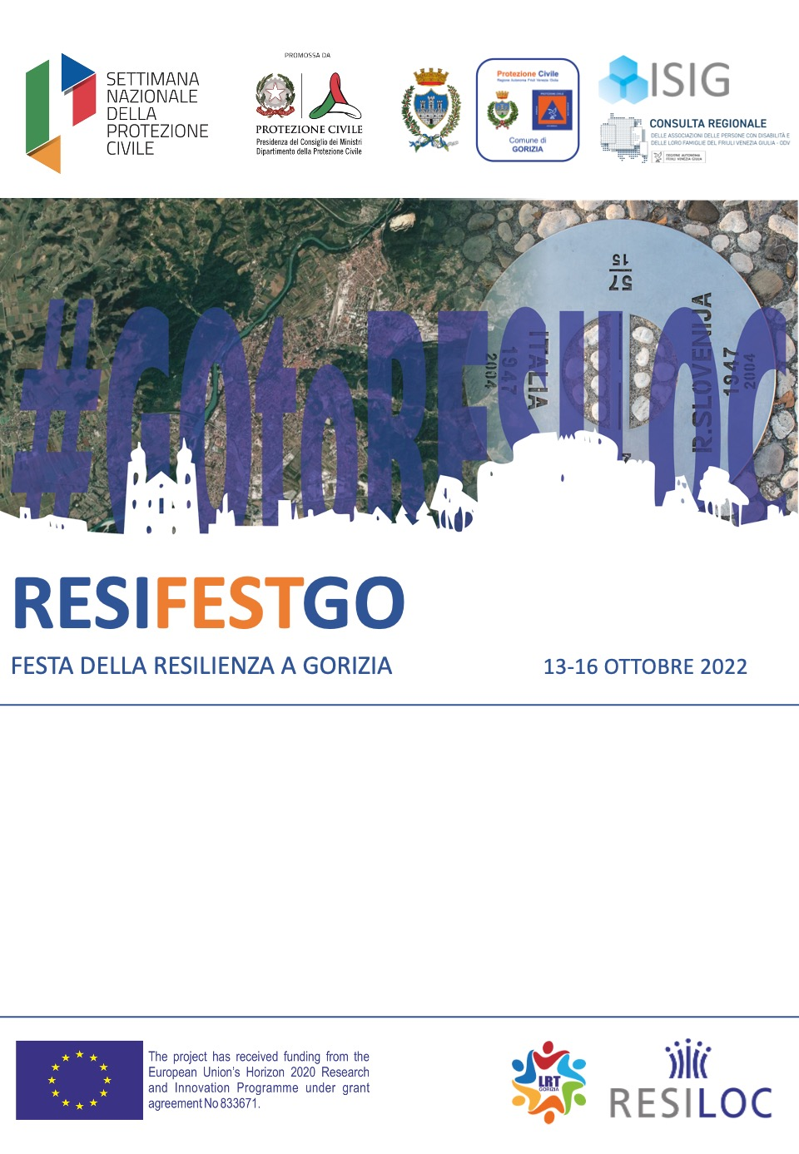

Technical Workshop “From emergency management to community resilience”
  - 13 October 2022
  - City Council Hall, Municipality of Gorizia, Piazza Municipio, 1, Gorizia

Technical Workshop “From emergency management to community resilience: European best practices and lessons learnt on the management of wildfires”
13.10.2022 - 14:00 – 18:30 – City Council Hall, Municipality of Gorizia, P.zza Municipio, 1, Gorizia
Technical seminar aimed at emergency experts and professionals to share experiences and analyse the recent impacts of fires in the Italy-Slovenia cross-border area, also in the light of European experiences.
Audience: Local authorities, Emergency operators, Volunteers
Working language: Italian, English, Slovenian
Moderator: Daniele Del Bianco, Director, Institute of International Sociology of Gorizia

14.00 – 14.45 First session – July 2022: the experience of local communities
Francesco DEL SORDI Councillor for Civil Protection, Municipality Gorizia, Italy
Mauricij HUMAR Mayor of Miren-Kostanjevica Municipality, Slovenia
Fabio VIZINTIN Mayor of Doberdò del Lago Municipality, Italy

14.45 – 15.45 Second session – European Best Practices
Jon HALL Director, Resilience Advisory Network (RAN), UK
Gasper BIZJAK Firefighter Specialist, Federation of European Fire Officers (FEU), Slovenia
Jose ALMODOVAR Forest fire expert, Castilla-La Mancha, Spain
Katja BANOVEC JUROS Administration for Civil Protection and Disaster Relief, URSZR Slovenia
Miguel ALMEIDA Firefighter Specialist, ADAI, Portugal

15.45 – 16.00 Break

16.00 – 17.30 Third session – July 2022: lessons learnt
Massimo STROPPA Director, Regional Forest Rangers of Friuli Venezia Giulia, Italy
Stanko MOČNIK Commander, Gasilzka Enota Regione nord Primorska, Slovenia
Alessandro Giuseppe GRANATA Commander, Provincial Fire Brigade of Gorizia, Italy
Simon VENDRAMIN Commander, Gasilzka Enota Nova Gorica, Slovenia
Alessandro RESCIO Commander, Police – Traffic and Highway Department, Italy
Tadej DEVETAK President, PGD Šempeter Pri Gorici, Slovenia
Nazzareno CANDOTTI Director of Volunteering Service, Regional Civil Protection – Friuli Venezia Giulia, Italy

17.30 – 18.15 Debate

18.15 – 18.30 Conclusions
Francesco DEL SORDI Councillor for Civil Protection, Municipality Gorizia, Italy

